**Baseline Ecommerce Conversion Rate (GA4 Demo Account – Merchandise Store)**

For this project, I am analyzing **ecommerce conversion rates**, which represent how effectively a website turns visitors into paying customers. To begin, I explored the **Google Analytics 4 (GA4) Demo Account – Merchandise Store**, which provides access to real ecommerce data. Using this demo dataset allows me to practice on real-world information without needing a personal ecommerce site.

The purpose of this step is to capture screenshots that show **key baseline metrics** such as conversion rate and purchase revenue. These screenshots serve as evidence that I can navigate GA4 and extract the important KPIs relevant to conversion analysis. By documenting them, I create a reference point that will support deeper analysis later, such as funnel drop-offs, revenue patterns, and product performance.

In short, this file ensures that the project starts with a **clear, data-backed foundation**, linking the GA4 demo environment to my analysis work.

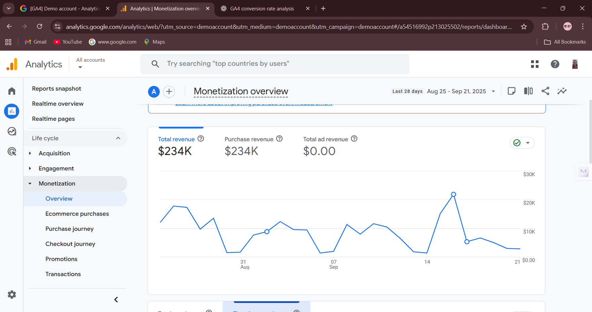

1. Screenshot 1: Revenue Trends (Line Graph: Months vs. Money)

**What it shows:** Revenue flow over time (monthly trend) + summary metrics (Total Revenue, Purchase Revenue, Ad Revenue).

This graph highlights how total revenue, purchase revenue, and ad revenue fluctuate across months. It provides a timeline view of performance, helping to identify peak and low revenue periods. This baseline revenue trend is important for comparing with conversion rate patterns later

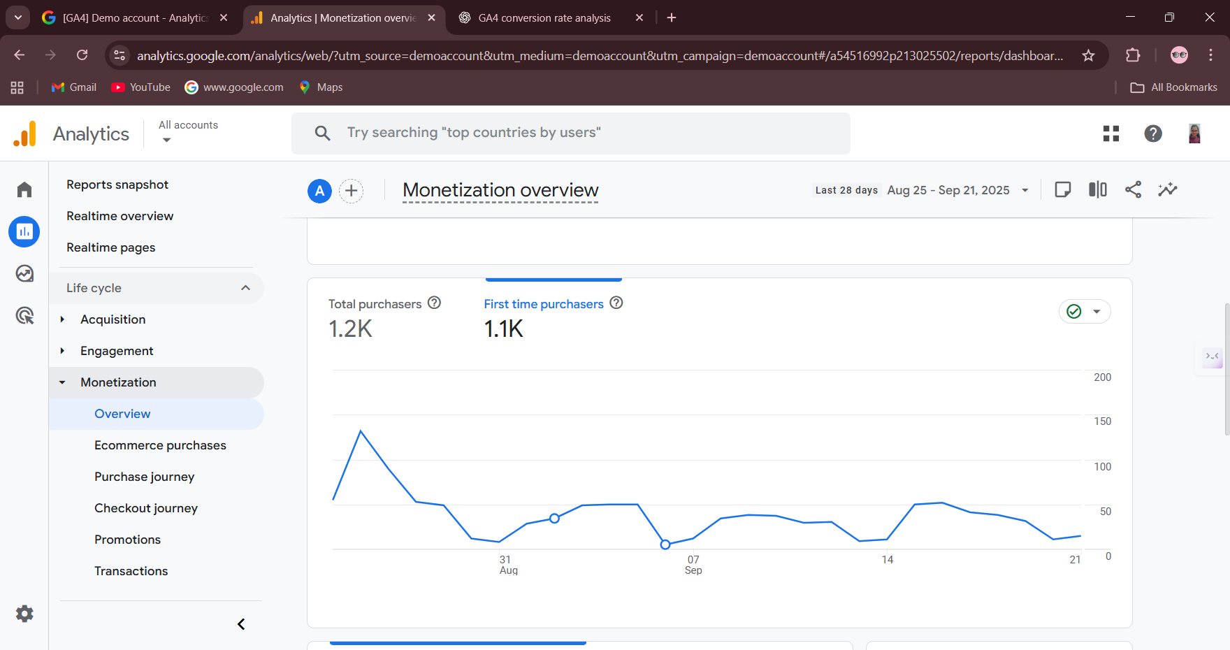

**Screenshot 2: Purchaser Trends (Line Graph: First-time vs Returning Purchasers)**

•**What it shows:** Growth of new customers vs repeat customers.  
*This chart shows the number of first-time purchasers compared with total purchasers. It helps to understand whether revenue growth is driven mainly by attracting new customers or by retaining existing ones. This insight supports conversion analysis by connecting customer loyalty with revenue outcomes.*

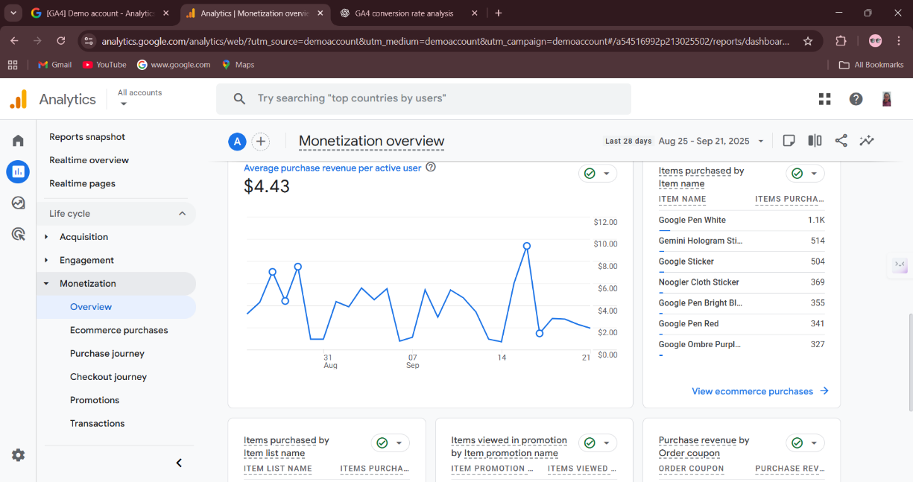

**Screenshot 3: Average Purchase Revenue per Active User**

* **What it shows:** Average spending per active user.
* **How to explain:**  
  *This chart displays the average purchase revenue generated by each active user. It provides insight into customer value, showing how much each active user contributes on average. This complements conversion rate analysis by linking not just how many people convert, but how much value each conversion brings.*

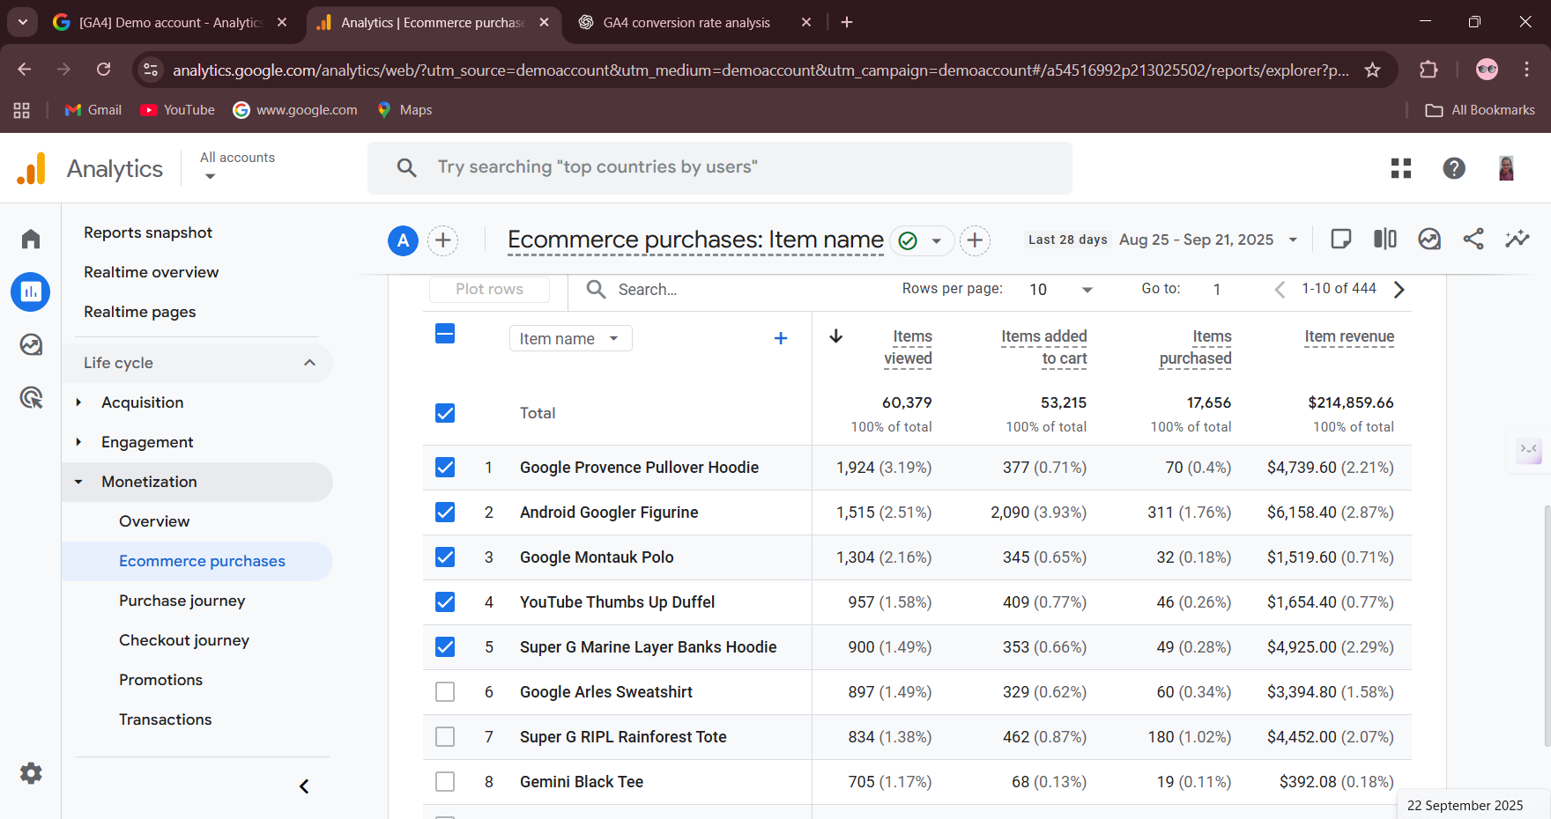

**Screenshot 3:**  **Top-Selling Products and Conversion Breakdown**

* **What it shows:** A ranked list of **top-selling products** in the Merchandise Store.

The Ecommerce Purchases report provides detailed insights into product-level performance. For instance, while some products have high view counts, their purchase conversion rates are relatively low, indicating possible pricing or interest issues. On the other hand, certain products show strong conversion rates, contributing significantly to overall revenue. This analysis helps in identifying both high-performing products and those with potential for optimization.

**Key Learnings / Observations**

1. **Huge drop-off at purchase:**
   * Only **1.78% of total users** complete a purchase → main conversion problem.
2. **Device-wise differences:**
   * Mobile, Tablet, Desktop, Smart TV conversion % shows which devices have higher or lower drop-offs.
   * If mobile drop-off is very high, it indicates **mobile checkout or UI issues**.
3. **Intermediate steps (Step 2 & 3):**
   * Identify at which stage users leave (view → add to cart → begin checkout).
   * Step 3 missing data → cannot yet pinpoint exact drop-off points; once filled, you can see **biggest problem step**.